**Wolf’s Crossing’s E-book Collection**

**This collection can be accessed on any device that has an internet connection.**

1. Wolf’s Crossing’s web page: <http://www.sd308.org/wolfscrossing>
2. Click on the LRC tab in the middle of the screen.

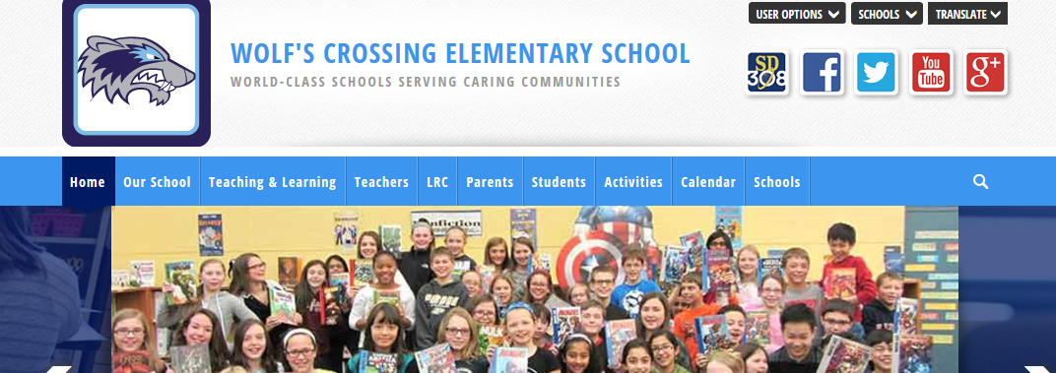

1. Under the Quick Links tab: click on Wolf’s Crossing Card Catalog

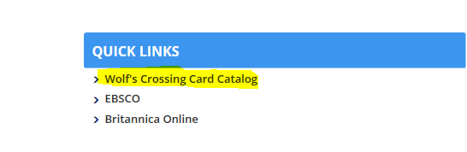

1. Choose Wolf’s Crossing Elementary from the school list on this screen

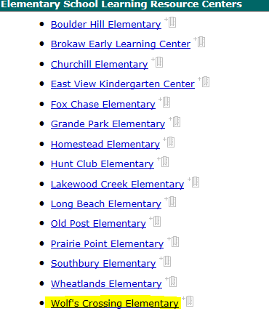

1. Click on the Catalog tab

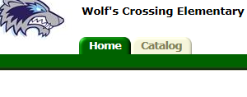

1. Click on the **Universal Search** tab, this will open our collection of eBooks.

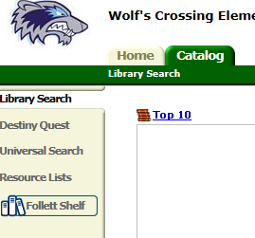

1. If you have made it to the screen below, you found our eBooks! Currently we have 62 titles that can be read at anytime, anywhere! We hope to add more titles to our collection.

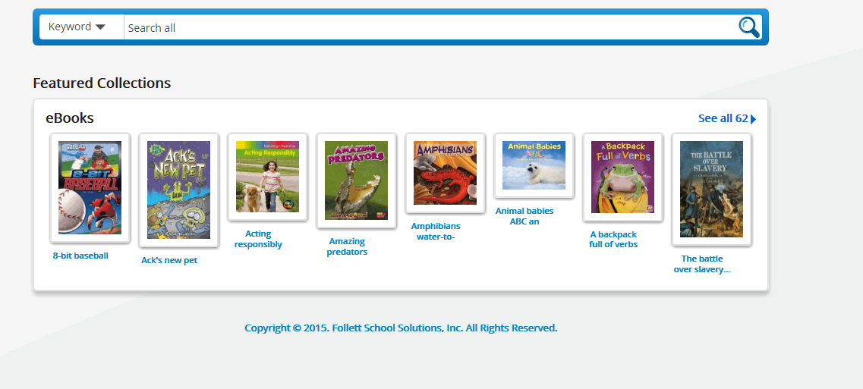

1. If you have trouble or a title suggestions please feel free to email me!

Thank you!

Mrs. Mahoney

Wolf’s Crossing Library Media Specialist

Cmahoney@sd308.org